Name | Sign/ logo | Domain | Description | Web site
Ducati komponenti d.o.o.  Zagorska ulica 6,  42230 Ludbreg  Varaždin county | 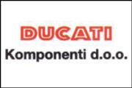 | Production of generators, rotors, stators, parts for marine engines, light planes and electrical parts for all types of electric bicycles.  Development of new products. | Part of grupation Ducati Energia S.p.A., Italy. Company started the production in 2002. Delivers the products all over the world. From 2007. company is doing business indipendent of the parent company.  From 2009. the company has Development center that produces new products that use green energy and take care of environmental protection. The company also has the logistics center that deals with import and export for the whole company Ducati Energia in Europe, part of Asia and north America. | www.ducatienergia.it
Solvis d.o.o.  Cehovska 106  42000 Varaždin |  | Producer of fotovoltaic modules. | Croatian producer of fotovoltaic modules. Present on the global market from 2009. with a dedication to produce environmentaly friendly and affordable source of energy. | http://www.solvis.hr
Include d.o.o.  Don Frane Bulića 183a  21210 Solin |  | Producer of smart street furniture called Steora that uses Solar energy to produce electricity. | A European hardware company, founded by a 22-year-old innovator Ivan Mrvoš. The company earned recognition following a large investment in 2017, quickly becoming one of the best producers of smart street furniture in Europe. Based in Solin, Croatia, in a 2000 m² facility, the company has 35 highly educated employees. Include has global footprint of more than 400 benches on 20 markets around the world. They are part of the most significant ‘Smart city’ projects and present in 125 cities and municipalities on 5 continents. | https://www.include.eu/  https://steora.com/cro.html
Eko-monitoring d.o.o.  Kučanska ulica 15  42000 Varaždin | 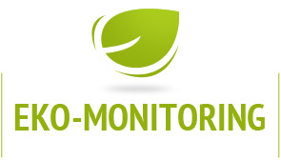 | Offers service of making documents about environment protection, occupational safety, technical inspection and mechanical services. | Company is founded in 1999. and has several employees that are highly educated. They offer making documents like Environmental impact studies, Safety statement, Waste management report, Waste management plan, Report to the Register of pollutants, Water right permit etc. Company offers expert councelling about environment protection, sustainable waste management, use of web aplication BAGOT for waste management. Company does measurements of air pollutants, sewage watertightness and inspection of sewage and water supply systems. | http://eko-monitoring.hr/
Eco mobile d.o.o.  Samoborska 266  10090 Zagreb |  | Eco mobile is company specialized for development, production and implementation of advanced ICT solutions to support waste management. | Their products are: system for electronic evidence of waste pickup, Smart Waste system for measuring container fill level, Handheld RFID/barcode reader, EcoMobile Cloud hardware and software package, EcoMobile smartpass waste bin identification system for wireless data transfer. | https://www.ecomobile.hr/en/
EDC d.o.o.  Ul. Antuna Štrbana 18  10000 Zagreb |  | Company offers IMAGIS geographic information system and they have developed telemetric hydrant. Along with the basic function of enabling the water supply for firefighting purposes, telemetric hydrant enables measuring, collecting, processing and transferring data to the center for monitoring and managing the water supply system. | EDC d.o.o is a company founded in 2002 by a group of engineers who already had 15-year work experience in development, design, monitoring and information technology in Zagreb water supply and drainage system. Thanks to its hardworking employees, their knowledge and commitment, EDC has become a renowned company in the field of utility management. The quality of our services in GIS design, from field survey to customer support, is already legendary. Our IMAGIS utility web GIS is open and accessible system with many unique features. On that note, EDC d.o.o. has also introduced Telemetric Hydrant: innovation patented by Croatian experts. As a general distributor of Olympus Industrial Equipment, EDC already has a regional significance. | http://www.edc.hr/en/
Byte lab grupa d.o.o.  Dragutina Golika 63  10000 Zagreb |  | Company offers electronic solutions, firmware development and hardware production. They are specialized for build in devices -form planning to final product, made by customers needs. | Some of the products that Byte lab developed are: telemetric device for machines, tracking and locating system, smart meters for water and gas, bluetooth smart hardware and software, RFID/NFC readers, touch screen build in computer and waste management solutions. | http://www.bytelabgrupa.hr/
Eko-Adria d.o.o.  Boškovićev uspon 16  52100 Pula | 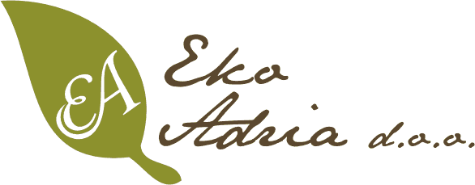 | Provides complete environment protection service. | Company exists for 15 years. Their employees come to each potential customer and help them match their business with Environmental protection law, Sustainable waste management law and all other legal acts that must be obeyed. | http://ekoadria.hr/
Eko prijevoz d.o.o.  Vodovodna 20a  10000 Zagreb | 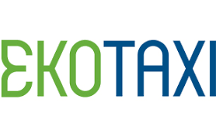 | Company offers taxi ride and uses hybrid cars. | Company exists since 2011. in Zagreb and Zaprešić. The hybrid cars they use produce 50% less CO2 and have improved safety features. In the year 2012. the company Eko prijevoz was awarded with Green Superbrand 2012 award. | http://www.ekotaxi.hr/
Ires ekologija d.o.o.  Prilaz baruna Filipovića 21  10000 Zagreb |  | Company offers consulting about environmental impact and their mission is to make your ideas into environmentally friendly projects. | Company takes customer´s project and prepares suggestions how to adapt it to environmental regulations and law. They follow the realization of the project form the beginning and later they perform monitoring. | https://ires-ekologija.hr/
Eko invest d.o.o.  Draškovićeva 50  10000 Zagreb |  | Company makes programs for environment protection, makes reports, prepares projects and translations. | Company exists for more than 20 years, doing environmental projects and consulting. They help customers to get to know regulations about environment protection vali din Europe and internationally.They translate professional documents to English, German, Italian and French language. | http://www.ekoinvest.hr/
N.T.-eko d.o.o.  Grančarska V.odv.br.2  10257 Kupinečki Kraljevec |  | Company offers waste disosal service, especially for liquid waste. | Cmopany was founded in 2005. and their mission is protection of nature from harmful human impact. They own 6 specialized vehicles for toxic and non-toxic waste transport. After collecting the waste, they do waste treatment. | http://www.nt-eko.hr/index.htm
Domus futura d.o.o.  Trg Lovre Matačića 9  10360 Zagreb |  | Company produces prefabricated houses, made from sustainable materials and recycled materials. | Company was founded in 1990. As employees got more experienced and educated, they recognized the need for saving energy and making their business sustainable. They build houses for the future that help people save energy, keep the environment healthy and look nice and modern. | http://euroekodom.hr/
Telluri Medin d.o.o.  Zore Dalmatinske 6  23000 Zadar |  | Company promotes ecological, country, health and gastronomic tourism and agriculture. | Established in 2007. as the only company in Europe that produces Californian red worm and Mediterranean snail for use in gastronomy. | http://telluris-medin.hr/telluris/eng/index_eng.html
FABULA j.d.o.o.  Pavleka Miškine 39  42000 Varaždin |  | Company produces the most sustainable pencil in the world. | Fabula pencil is made from recycled coffee, tea and flowers, quality HB graphite and inside top of the pencil there are seeds. When usin the pencil the shavings can be added to plants because they are biodegradable and nurture plants. | http://www.fabulaorganicpencil.com/

