Practice tasks for students
-students form groups and work on a given assignments
- Job advertisement

- each group of students write their own adverts and show them to the rest of the group
- what do you want from your employee
- what qualities your future workers should have
- what can you offer in long term to the candidate

How to do it?
-be careaful not to confuse job ads with job description!
-job description is a detailed description of the responsibilities and expectations for a job that company uses internally
-job advertisement is made to attract candidates in your company and team; it has to emphasize all the reasons that make working for you great
-job advert sells the job

What to write?

- Job title + include the name of the position and the top 1-3 things that will make the job attractive to the applicant
- Introduction – give 3-5 details that applicant will find most exciting about the job
- Company information – how many years you´ve been in business, how long employees stay to work for you, interesting projects or clients, equipment, awards, work culture facts
- The position – provide information about work hours, pay, co-workers, education opportunities, benefits
- Location- give details about schools, activities, crime rates, other things to do after work in the local area ( moving can be obstacle to anyone considering your job that doesn´t live in the area)
- Why should someone apply for the job – repeat top 5-6 reasons mentioned before

- Job application
-make sure you write letter or e-mail that gives the right impression
-read the job advert closely so you can tailor your application to the requirements of the job
-research the organization- that will show you are really interested
How to compose the application?
-keep it brief, give clear and concise explanation of your suitability for the job
-begin the letter with Dear Mr/Mrs/Ms XXXX , or Dear Sir or Madam
-avoid inappropriate language, slang or technical jargon
-use brief, informative sentences and short paragraphs
-check your spelling, grammar, and punctuation
Structure of the job application
1. The position applied for + mention where you saw the job advert
2. Your current situation (your current job, current skills or responsibilities)
3. Reasons why you want the job – be clear and positive, outline the qualities and skills that you believe you can bring to the job or organization
4. Closing paragraph- say when you would be available to start work, or suggest that they keep your application for some future opportunity
5. Signature- in a letter always sign it and type your name underneath your signature
Speculative job application
- when you send application to a company you really want ot work for, but they haven´t put the job advert
- you describe the type of job you are interested in, and outline what skills and personal qualities you have to offer

- Job interview
-both sides have to be prepared
-employer has to ask questions to make sure the candidate is what he wants for the job
-the candidate has to respond effectively, think about common questions and what to say- prepare in advance
Some of the usual questions:
1. What is your greatest strength?
2. What is your greatest weakness?
3. Tell me about yourself (note- try to share some of your personal interests which don´t relate directly to work)
4. Why should we hire you?
5. What are your salary expectations?
6. Why are you leaving or have left your former job?
7. Why do you want this job?
8. How do you handle stress and pressure?
9. Describe a difficult work situation and how you overcame it?
10. What are your goals for the future?
11. How do you handle failure?
12. Do you work well with other people?
13. What can you do better for us that the other applicants?
Inappropriate or illegal questions:
-only information relevant to your ability to do the job can and should be asked
-most discrimination is not deliberate- the interviewer may be ignorant of the law
-inappropriate questions are about: age, ancestry, credit, criminal record, disability, family status, gender, military discharge, religion, race, skin color, sex, birthplace, marital status

- SWOT analysis of your company

-made by each member of the team separatley, and then all join together to compare what they wrote
-made by the whole group, with discussion about each category

Strengths | Weaknesses
Opportunities | Threats

- One-page business plan
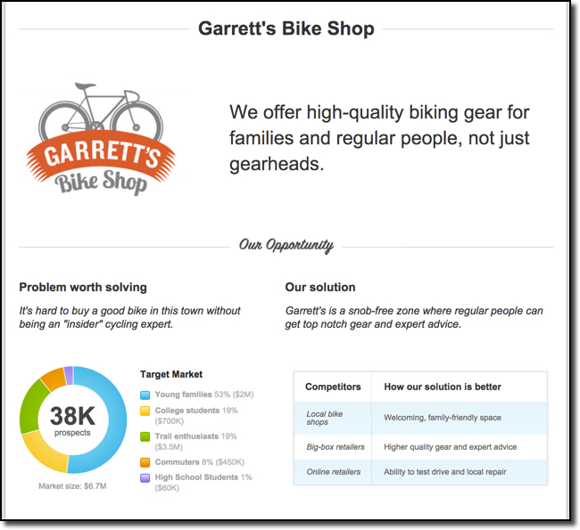
- Present your company to investors
-entrepreneur should inspire and engage the investors
-don´t bombard the investors with dana and boring PowerPoint slides
What to do to win over the investor?
- Tell stories
Speak about a personal story, innovations, experiences and be emotional.
-some investors say: ˝The most memorable presentations don´t start with dana. They start with a compelling personal story. Iti s not about the dana; it is about engagement.˝
2. Use pictures to tell stories – pictures are more memorable than words
3. Express your passion- because the investors want someone passionate about the business

- Sell your product to a customer

-selling is about understanding the customers needs
-everybody makes mistakes at sales conversations, and you cannot expect to win a customer every time

Some of the things you shouldn´t do:
-talk too much or too little
-ask a lot of questions
-talk too little so the buyer has control to the conversation
-be over eager, so the buyer can ˝smell˝ your despiration
-be unprepared, so the buyer wonders why they are waisting their time with you
-be uncomfortable talking about money

How to improve your sales converstions?
1. Build relationship with a customer- talk with the customer about his/her problems and how you can help them;
2. Discover the customer´s needs, problems, plans for the future, goals, dreams and desires – this way you can help them achieve their goals
3. Explain how using your product could change the customer´s world, help them visualize the change and build excitement around it
4. Balance between you talking and listening
5. TRUST is the foundation of sales success- a buyer will never see the full value of what you propose if they don´t trust you
-for that to happen you have to be an expert on the topic you talk about, demonstrate moral principles because it shows you have the customer´s best interests in mind, and connect with the buyer on a personal level
6. Plan to succeed – prepare yourself and know what you want to get out of the conversation – that way it is much more likely to make a sale

