ONE-PAGE BUSINESS PLAN

Why Experts are Advocating a One Page Business Plan
With simpler, to-the-point methods becoming the norm, many entrepreneurs have turned to 1 page business plans in order to get their businesses off the ground faster instead of opting for a detailed and time consuming approach. In case you had any doubts, here are the advantages of a one page business plan:
- Since your ideas are changing all of the time, it’s easy to update
- It provides clarity to whoever is reading it as important information sticks out
- It’s a good way to generate interest around a business concept
- It will assist you with your pitch
- It offers a more affordable approach to product testing and development
- It helps get your entire team onboard with the company vision and goals
- With the plan having very specific goals you can create a straight forward strategy around each of them
- It eliminates the need to find an excuse not to plan and grow.
It consists of the following parts:
- Customer Segments: Who are your mass and niche markets?
- Value Proposition: What are you offering and why are you different?
- Channels: Look at the phases your product goes through. This is everything from awareness and distribution to after-sales service.
- Customer Relationships: How are you building relationships with customers and is it working?
- Revenue Streams: Look at what you are charging and if you could be charging more. How are you receiving your payments and does it contribute enough to overall revenue?
- Key Resources: What resources do you require to function? These can include physical, human, financial and intellectual.
- Key Activities: Ask yourself what activities need to take place to deliver on your value proposition?
- Key Partnerships: Write down who your key suppliers and partners are and how they contribute to your overall goals.
- Cost Structure: Look at fixed and variable costs so that you can see what can be improved upon.

Example 1:
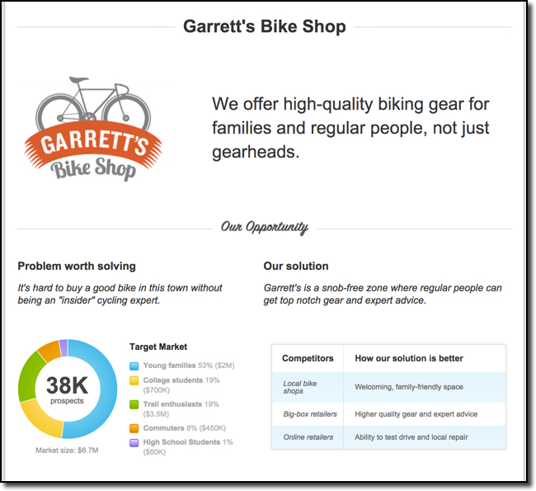
Example 2:
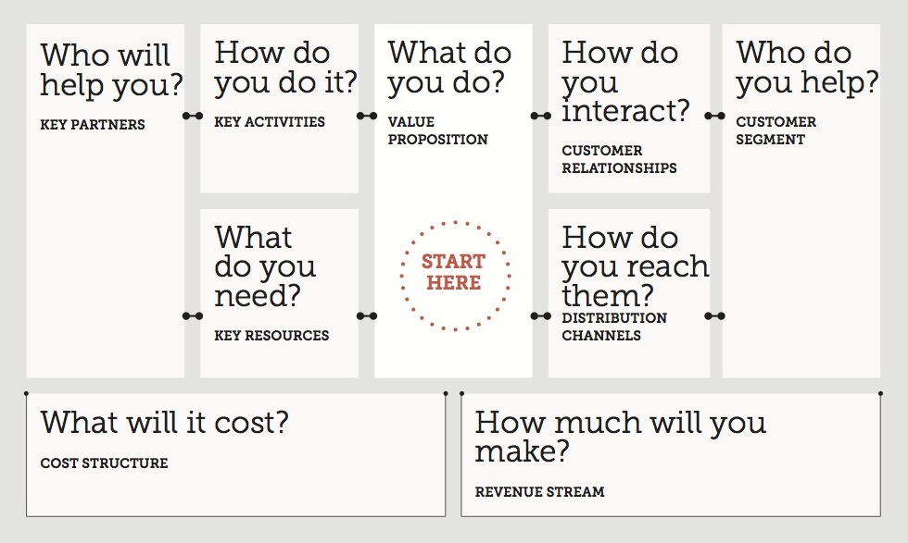
FORMAL BUSINESS PLAN
- Executive Summary [In 2 pages or less summarise the most important aspect of the business]
Business Concept:
Financial Features:
Financial Requirements:
Current Business Position:
Major achievements:
- General Company Description [1-2 page overview of the company]
Name of the company
Type of legal entity
Ownership
Significant assets
Mission statement
Goals and objectives
Company strengths and core competencies
- The Opportunity, Industry & Market [2-3 pages]
The Opportunity
- Where is the gap in the market?
- What has given rise to this gap?
- How was this gap identified?
- How will the gap be filled?
The Industry
- What are the barriers to entry in this industry?
- How much power do the customers have?
- How much power do the suppliers have?
- Are there substitute offerings for the product or service?
- Who are the competitors and how strong is the competitive rivalry?
- What are the major changes affecting the industry?
The Market
- What is the total size of the market?
- How fast is the market growing?
- What percentage share of the market will you have? (This is important only if you think you will be a major factor in the market.)
- What are the major trends in target market – trends in consumer preferences, demographic shifts and product development?

- Strategy [1-2 pages]
- The focus of the business: broad mass market or a specific niche?
- How the business will succeed in the market? How will you create a unique and valuable position, involving a different set of activities?
- What is unique about the business? How is the offering different from that of competitors?
- What is the value for the customers? Describe the value proposition for the customer?

- Business Model [1 page]
- The sources of revenue
- The major costs involved in generating the revenue
- The profitability of the business (revenue less costs)
- The investment required to get the business up and running (to get to scale)
- The critical success factors and assumptions for making the profit model work

- Team – Management & Organisation [2 pages]
- A list the founders including their qualifications and experience
- A description of who will manage the business on a day-to-day basis. What experience do these individuals bring to the business? What special or distinctive competencies do they offer?
- An organisational chart if you have more than 10 employees, showing the management hierarchy and responsibility for key functions

7. Marketing Plan [2-3 pages]
- The product (or service) and why it is valuable to customers
- The focused and detailed description of the target market
- The positioning of the product or service – how it should be perceived by customers
- The pricing strategy with specific price points at which the product or service will be sold
- The sales and distribution channels that will be used to get the product or service to the customer
- The promotion strategy including public relations activities, specific promotions, advertising and intended viral marketing activities

8. Operational Plan [2 pages]
- A description of the operating cycle that describes what the organisation will do to deliver its service or create and sell its product
- A description of where all the necessary skills and materials will be sourced
- What will be outsourced, what relationships are in place and how those relationships will be managed
- The cash receipts and cash payment cycle of the business

9. Financial Plan [2-4 pages]
- Start-up expenses and capitalisation: a description and explanation of what it will cost to launch the business and where you expect to get this money
- 12-month profit and loss projection (month-by-month) and a three-year profit and loss projection (quarter-by-quarter)
- A 12-month cash-flow projection and a three-year cash-flow projection (quarter-by-quarter)
- A projected balance sheet at start-up and at the end of years one to three
- A break-even calculation

